CanPower Skate

Skate Canada Programs: CanPowerSkate
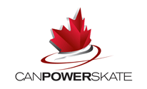
CanPowerSkate is geared to skaters aged approximately six or older who already have basic forward and backward skating skills (they must be able to skate the length of the rink using alternate strides) and are able to stop on command without use of the boards. For safety reasons participants are required to wear full hockey/ringette equipment that is CSA approved.

CanPowerSkate's Pre-Power is designed for young skaters, approximately four to six years of age who can stand up on skates and move forward (shuffle, walk or glide) who may not be ready for CanPowerSkate Level 1. Pre-Power helps develop basic skating abilities in a power skating-specific environment, including balance skills, forward and backward skating, stopping, turning and agility skills. The curriculum is presented in three progressive levels complete with its own awards to encourage participation and motivate skaters. Pre-Power has been designed to run concurrently with CanSkate sessions.

What are the benefits of Participating in CanPowerSkate?
CanPowerSkate is the only nationally regulated power skating program in Canada. It was developed by a team of hockey, figure skating and ringette experts to teach the fundamentals of power skating in a progressive and sequential manner.
When you/your child registers for a CanPowerSkate program at your local Skate Canada club, you also become a member of Skate Canada, the national sport governing body for figure skating in Canada. Membership benefits in the CanPowerSkate program can include:
- participation in a unique skill testing system which includes award bars and ribbons
- parent information sheets
- progress updates and report cards
- special CanPowerSkate events and club functions
- opportunity to be talent-scouted
- opportunity to participate in a healthy lifestyle activity
These are some of the awards and incentives that have been developed to encourage athletes in CanPowerSkate:
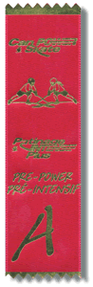  CanPowerSkate  Pre-Power Ribbon | 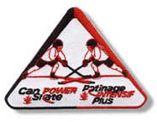  CanPowerSkate Participant Badge
 | CanPowerSkate Badge

How does CanPowerSkate work?
The CanPowerSkate program consists of skills divided into six levels, arranged in progressions gradually increasing in complexity. Levels 1 to 3 focus on the fundamentals of skating, Levels 4 to 6 place additional focus on the acquisition of efficient technique, speed, agility, technical aspects of stride and acceleration and skating with the puck/ring. Skaters are evaluated on skill level and are timed as they perform a test involving skills in a course-like pattern. The skater receives a mark combining his skill performance plus test time. This determines whether the skater receives a Bronze, Silver or Gold award bar for that Level.
Please note: The CanPowerSkate program is exclusive to Skate Canada and is available only to Skate Canada member clubs and sanctioned skating schools. All participants must be registered with Skate Canada. Only Skate Canada member Coaches trained and certified at a CanPowerSkate Coaches Course are qualified to instruct the CanPowerSkate program.

