Calalta Figure Skating Club has a highly qualified team of professional coaches who work together to ensure that each skater achieves personal excellence. Our coaching team includes international level coaches in Singles, Pairs, and Dance. All of our coaches have been certified through the National Coaching Certification Program (NCCP) and abide by Skate Canada's Coaches’ Code of Ethics. In addition, many of our coaches have been trained in Dartfish video technology, an advanced software program that enhances performance analysis.
The Calalta coaching team asks that all skaters and parents adhere to the Calalta Figure Skating Club policies and Skate Canada's Parent Code of Conduct.
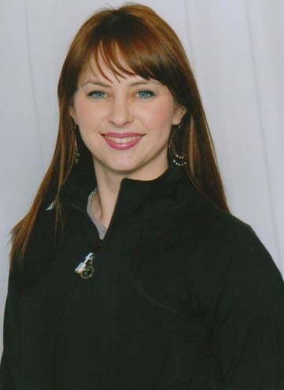  Coaches at Jimmie Condon and COP | JAIME-LYN JACKSON - Director of Group Skating  (403) 690-9598  Calaltagroupprogramsdirector@gmail.com  Skating Accomplishments: Former “Disney on Ice “Professional Skater; Former National Competitive Senior Synchro Skater; Gold Dance, Gold Skills, Sr. Silver Free Skate elements  Coaching Accreditation/Education: Certified Provincial Coach and can power certified. 15 years coaching experience. Analyze Technical & Tactile Performance Course, CanSkate University recipient. Developer and coach of Sectional, StarSkate champions and Alberta winter games medalist. Coach in both Competitive and StarSkate streams. Specialize in early development.  Coaching Venue: Jimmie Condon & COP  Days available: Monday to Saturday  Coaching Area of interest: Free skate and skills  Accepting new students: on an individual basis  Coaching rate: $13.50 per 15 minutes
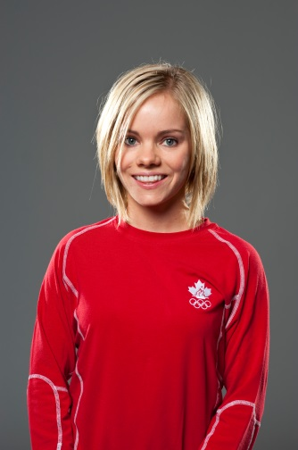  Coaches at COP | ANABELLE LANGLOIS  langloishaycoach@hotmail.com  Skating Accomplishments: 2002 & 2010 Canadian Olympic team member, 2008 Canadian Pair Champion, 6 times world team member, 8 time national medalist  Coaching Accreditation/Education: Certified National Coach, High Performance Coach-International, gold status, coach of provincial, challenge & national champions.  Coaching Venue: COP & JCA  Days available: Monday to Friday  Accepting new students: Yes, all levels, focussing on the development of future competitors  Coaching Area of interest: Competitive singles and pairs training from Pre-Juv to Sr.  Coaching rate: $17.50 per 15 minute lesson
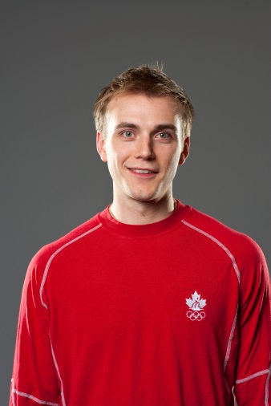  Coaches at COP | CODY HAY  langloishaycoach@hotmail.com  Skating Accomplishments: 2010 Canadian Olympic team member, 2008 Canadian pair champion, 3 times national medalist, 3 times world team member  Coaching Accreditation/Education: Certified National Coach, High Performance Coach-International, gold status, coach of provincial, challenge & national champions  Coaching Venue: COP  Days available: Monday to Friday  Accepting new students: Yes, all levels, focussing on the development of future competitors  Coaching Area of interest: Competitive singles and pairs training from Pre-Juv to Sr.  Coaching rate: $17.50 per 15 minute lesson
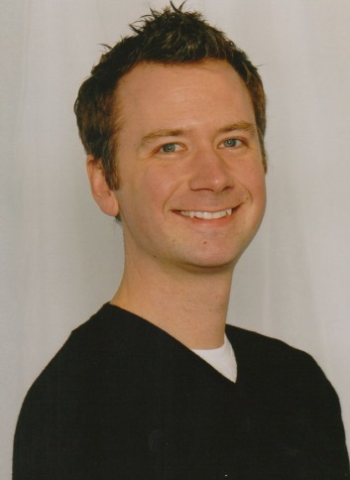  Coaches at COP | JEFF LANGDON  (403) 807-9212  jefflangdon421@hotmail.com  Skating Accomplishments: 4 time National Medalist, World and Olympic Team Member for Canada, Principal skater for Willy Bietak and Holiday on Ice Productions  Coaching Accreditation/Education: Certified National Coach  Coach of Provincial, Challenge, National, International, European, World and Olympic Competitors  Coaching Venue: COP  Days available: Monday to Friday  Accepting new students:  Coaching Area of interest: Pre-Juvenile to Senior competitive skaters  Coaching rate: $18.50 per 15 minute lesson
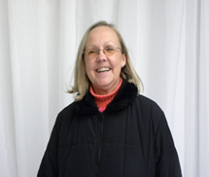  Coaches at Jimmie Condon | LAURIE FINNEY  (403) 287-3229  lauriejfinney@gmail.com  Skating Accomplishments: Gold Figure, Gold Freeskate, Gold Dance  Gold Free Dance, Gold Pairs. Former Alberta Senior Champion and National Competitor - Novice, Junior and Senior  Coaching Accreditation/Education: 40 Years Coaching experience  Coach & Trainer of Provincial Champions, Divisional Competitors, National & International Competitors, Coach & Trainer of Divisional, National, and International Medalist  Coach of Canada Winter Games Competitors  Mentor Coach Level I, II and III  Certified National Coach  Coaching Venue: JCA  Days available: 7 days a week  Coaching Area of interest: All disciplines  Accepting new students: Yes  Coaching rate: $17.00 per 15 minute lesson
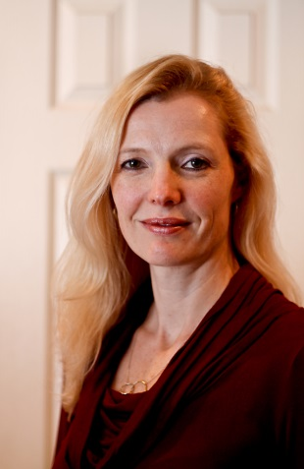  Coaches at Jimmie Condon and COP | Alison Bonney-Gregson  (403) 606-9068  alisonskates@gmail.com  Skating Accomplishments: Diamond Dance, Gold Freeskate, Novice Competitive Test, 7th Figure, Competitive Skating Skills Class 1 equivalency. Former PreNovice Ladies Champion, Alberta/NWT Sectional Championships  Coaching Accreditation/Education: Certified National Coach  NCCP Level 3 Trained Ice Dance  21 years coaching experience  Coaching Venue: Jimmie Condon & COP  Days available: Sunday to Friday  Coaching Area of interest: Dance, Freeskate & skills  Accepting new students: Yes, all levels and discplines  Coaching rate: $16.00 per 15 minute lesson
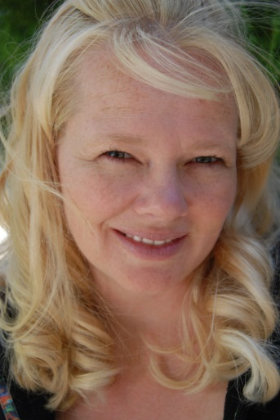  Coaches at COP | CHANTELLE PORTZ  chantelle@portz.ca  Skating Accomplishments:  Coaching Accreditation/Education:16 years coaching experience  Certified Provincial Coach, National Coach Trained, Level 3 (partial), CEP Gold Status, Certified CanPower  Coaching Venue: COP  Days available: Monday to Friday (JC Available for bookings)  Coaching Area of interest:  Accepting new students: Yes  Coaching rate: $15.00 per 15 minute lesson
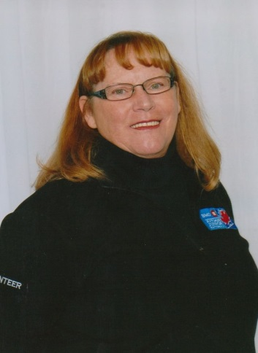  Coaches at Jimmie Condon | CATHY SAHALUK  (403) 244-9020 (h)  (403) 650-8390 (c)  cathy_sahaluk@shaw.ca  Skating Accomplishments: 6th Figure, Sr. Bronze Free Skate, Gold Dance, Ten Fox Variation and Bronze Rhythm Dance  Coaching Accreditation/Education: 44 years coaching experience, Mentor Coach level 1, Certified Provincial Coach, level 3 in training  Coaching Venue: Jimmie Condon  Coaching Area of interest: All disciplines  Accepting new students: Yes  Coaching rate: $12.50 per 15 minute lesson
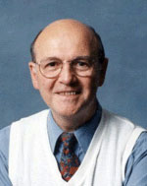  Coaches at Jimmie Condon | PAUL THOMAS  (403) 272-5125  wpthomas@telusplanet.net  Skating Accomplishments: Former British, European and World Ice Dance Champion  Coaching Accreditation/Education: Senior Instructor with 43 Years Coaching experience. National Competitive Coach - Singles and Dance  Coach of National Medalists, Coach of Canada Winter Games Competitors  Certified National Coach  Coaching Venue: Jimmie Condon Monday-Friday  Coaching Area of interest: All disciplines  Accepting new students: Yes  Coaching rate: $16.50 per 15 minute lesson
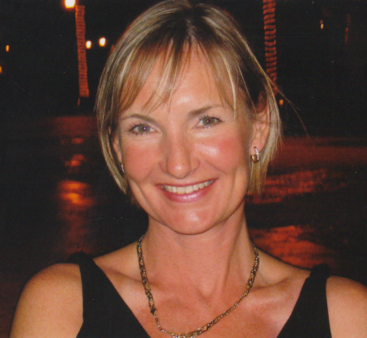  Coaches at Jimmie Condon and COP | KIM SLOPAK-WEEKS  toepik@shaw.ca  Skating Accomplishments: 7th Figure, Jr. Silver Free, Competitive Skating Skills Class 1. Diamond Dance Equivalency, Gold Free Skate, Sr Competitive Dance  Former National Team Member and International Competitor  Coaching Accreditation/Education: Certified National Coach / partial Level 4  Coached medalists at Skate Canada National Championships Calalta  Competitive Ice Dance Program Manager  Pre-Novice, Novice and Junior Teams competed in Cross-Border Internationals  Figure Skating Coaching Certificate from Seneca College  28 years coaching experience  Coaching Venue: Jimmie Condon & COP  Coaching Area of interest: Dance, Dance teams & Skills  Accepting new students: Yes, all levels and disciplines in September after I have confirmed who is returning  Coaching rate: $17.50 per 15 minute lesson
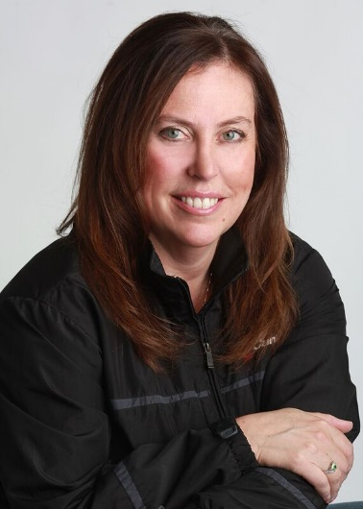  Coaches at COP and Jimmie Condon | Tammi Chudak  780-887-5902  sk8terchudak@gmail.com  Skating Accomplishments: Skate Canada Gold figure, Gold Freeskate, Novice Competitive, Gold Dances, Gold Skating Skills. Coach of Provincial, Challenge, and National Competitors in Singles and Pair skating  Coaching Accreditation/Education: 29 years coaching experience  Certified National Coach Level 3. CanPowerSkate Certified - 25 years experience working with all ages from tiny tykes to WHL  Coaching Venue: COP Monday - Friday  JCA Tues/Thurs mornings/evenings,  JCA Sunday mornings  JCA Mon/wed after 7:30pm  Coaching Area of interest: Free Skate/Skills  Accepting new students: Yes  Coaching rate: $16.00 per 15 minute lesson
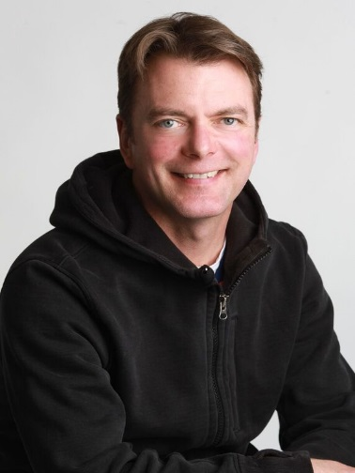  Coaches at COP and Jimmie Condon (Sunday) | SCOTT DAVIS  (403) 701-0330  scottgdavis@hotmail.com  www.davissportsenterprises.com  Skating Accomplishments: 1993 and 1994 United States Champion  1994 Winter Olympian, Coach and trainer of Vaughn Chipeur, 2010 Olympian  Coaching Accreditation/Education: Certified National Coach and High Performance Coach-World and Olympic  ISU Technical Specialist  Coaching Venue: Jimmie Condon & COP  Days available: Sunday to Friday  Coaching Area of interest: High performance coaching of competitive skaters from Juvenile to Senior  Accepting new students: On an individual basis  Coaching rate: $18.50 per 15 minute lesson
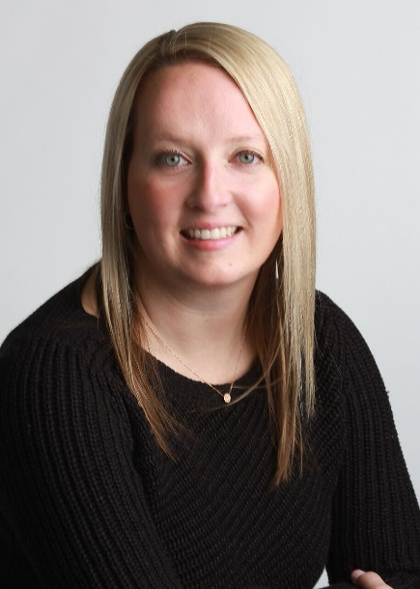  Coaches at Jimmie Condon | Andrea St.Cyr  andreastcyr@gmail.com  Skating Accomplishments:  Gold Freeskate, Gold Dance, Gold Skills, Ten-Fox Variation, National Open Synchronized Skating Champion, Ballet and Jazz Background  Coaching Accreditation:  19 years coaching experience  Certified National Coach Singles & Synchronized Skating Certified  CanPower Certified - CEP Gold Status  National Level Synchronized Skating Teams  National StarSkate Dance Biathlon and Singles Champions  Coaching Venue: Jimmie Condon Arena  Days Available: Tuesdays & Thursdays  Coaching Area of Interest: All disciplines-Freeskate, Dance, Skills and Synchronized Skating  Accepting New Students: Yes  Coaching Rate:$14.00
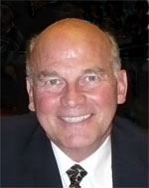  Coaches at JCA and COP | GREG FOLK  (403) 245-0833  ghfolk@shaw.ca  Skating Accomplishments:  Coaching Accreditation/Education: NCCP Level 4 Certified  NCCP Level 3 & 4 Course Conductor  Certified Corporate Performance Coach  Over 36 Years Coaching Experience  Master Coach Rating by NCI, PSA(PSGA), and the FSCC  Coach and Trainer of Provincial, Challenge and National Champions  Coach and Trainer of International, Junior World and World Competitors  Skate Canada Triple Gold Medalist - National Medalist in Junior and Senior Singles & Senior Fours  Coaching Venue:  Days available:  Coaching Area of interest:  Accepting new students:  Coaching rate: $20.00 per 15 minute lesson
Ben Westenberger
(403)604-8883
BFITCHER@hotmail.com

Skating Accomplishments: 9 Time National Competitor, 2011 World and ISU Four Continents competitor in Ice Dance.
Coaching Accreditation/Education: US Figure Skating Triple Gold Medalist in Ice Dance, Moves in the Field, and Free Dance. SkateCanada Triple Gold Medalist in Ice Dance, Free Dance, and Couples Interpretative. Coached skaters through their US and Canadian Gold, International and Diamond Dances. Coached skaters to the Canadian and US Nationals in ice dance as well as single skaters at the Regional and Sectional levels.
Coaching Venue: Jimmie Condon & COP
Days available: Monday through Saturday
Coaching Area of interest: All disciplines. Specializing in Ice Dance, Stroking, and Choreography
Accepting new students: Yes, all levels and disciplines
Coaching rate: $16.00 per 15 minute lesson
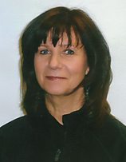  Coaches at Jimmie Condon | VALEEN HOLLAND  (403) 837-2684  hollandv@shaw.ca  Skating Accomplishments: Gold Figure, Gold Freeskate, Gold Dance  3rd and 4th Class I.S.U. Dance  2nd and 3rd Class I.S.U. Figure  Coaching Accreditation/Education: Over 45 Years Coaching experience. Certified Provincial Coach NCCP Level III Technical and Theory  Coaching Venue: Jimmie Condon  Days available: Monday to Friday  Coaching Area of interest: Dance & Skills  Accepting new students: Yes, all levels and disciplines  Coaching rate: $15.00 per 15 minute lesson
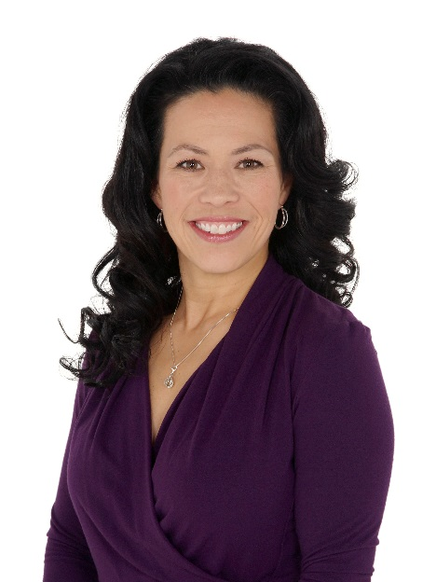  Coaches at COP and Jimmie Condon | Danielle Fujita  Skating Accomplishments:  Coaching Accreditation/Education: Over 25yrs of coaching experience  Skate Canada Coach Developer and Learning Facilitator  Graduate of Seneca College in Advanced Coaching Techniques  Graduate of MRU in Business & Marketing  National Coach Trained  Coaching Venue: Jimmie Condon & COP  Days available: Determined on an individual basis  Coaching Area of interest: Competitive Singles & Choreography  Accepting new students: On an individual basis  Coaching rate: $15.00 per 15 minute lesson
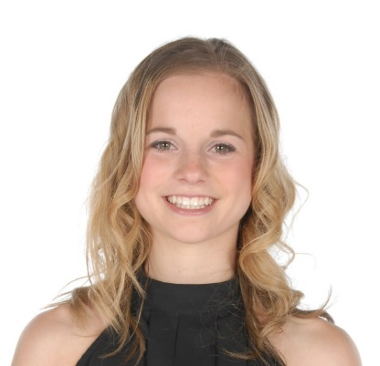  Coaches at Jimmie Condon | Erica Paxton  403-934-8679  e_risseeuw@live.ca  Skating Accomplishments: Two time British National Silver Medalist in pairs. Ranked 7th at the Europeans Championships in 2009. Junior Ladies Alberta Figure Skating Champion, and Western Canadians medalist. Principal Skater for Willy Bietak Productions. Gold Dances, Gold Freeskate, Gold Interpretive  Coaching Accreditation/Education: Certified Regional Coach  Coaching Venue: Tuesday and Thursday at JCA.  Coaching Area of interest:FreeSkate– All Levels  Accepting new students: Yes  Coaching rate: $16.00 per 15 min lesson
Coaches at Jimmie Condon | Robert Paxton  403-681-2024  paxton_robert@ymail.com  Skating Accomplishments: Two time Canadian National Medalist and National Team Member British National Champion and Medalist. Ranked 7th at the European Championships in 2009  Principal skater and Ice Cast Manager for Willy Bietak Productions  Coaching Accreditation/Education: Certified Regional Coach, CanPower Certified  Coaching Venue Tuesday, and Thursday evenings at JCA  Coaching Area of interest:FreeSkate– All Levels  Accepting new students: Yes  Coaching rate: $16.00 per 15 min lesson
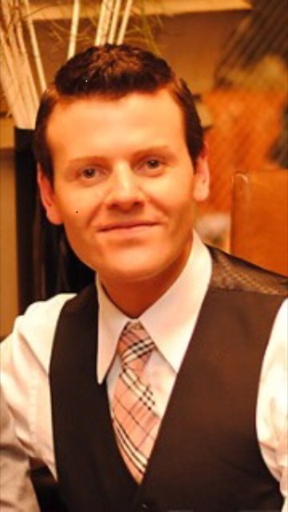  Coaches at | Tyler Myles  (403)909-7334  tyler_myles@rogers.com  Skating Accomplishments:  Novice and Junior Canadian Champion in Ice Dance  Senior National Team member and International competitor  Coach of International medallists at both the Junior and Senior level  Coached skaters to the 2014 Olympic Games and the 2011 - 2015 ISU World Championships  Associate Choreographer for the Stars On Ice tour  Coaching Accreditation/Education:  Certified National Coach  Technical Specialist in Ice Dance and Singles  Coaching Venue:  COP and J.C upon request  Days Available:  Monday through Saturday  Coaching Area of Interest:-High Performance Coaching and Choreography for Competitive skaters Juvenile through Senior in all disciplines  Coaching Rate:  $18.00 per 15 minute lesson
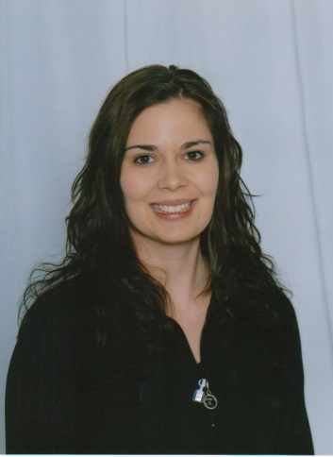  Coaches at Jimmie Condon | CANDACE CRAVEN  (403) 472-8844  coachcandace@hotmail.com  Skating Accomplishments: Gold Skills, Gold Dance, Gold Interpretive, Gold Freeskate Elements, Diamond Dances  Coaching Accreditation/Education: Certified Provincial Coach  Coaching Venue: Jimmie Condon  Coaching Area of interest: All disciplines  Accepting new students: All levels and disciplines on an individual basis  Coaching rate: $14.00 per 15 minute lesson
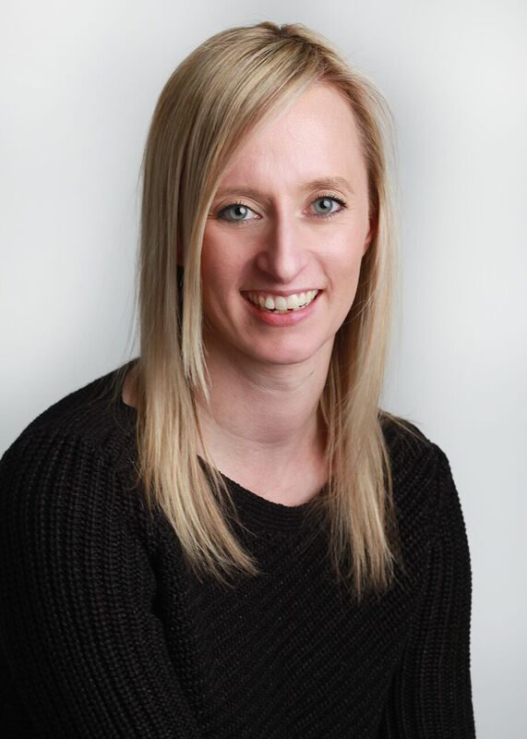 | Monique St.Cyr-Wasmann  mstcyr@gmail.com  Skating Accomplishments:  Gold Freeskate, Gold Dance, Gold Skills, Ten-Fox Variation, National Open Synchronized Skating Champion, Ballet and Jazz Background  Coaching Accreditation:  19 years coaching experience  Certified National Coach & Synchronized Skating Certified  CanPower Certified - CEP Gold Status  National Level Synchronized Skating Teams  National StarSkate Dance Biathlon and Singles Champions  Coaching Venue: Jimmie Condon Arena  Days Available: Tuesdays & Thursdays  Coaching Area of Interest: All disciplines-Freeskate, Dance, Skills and Synchronized Skating  Accepting New Students: Yes  Coaching Rate:$14.00

