Calalta FSC
2022-2023 Handbook
for
Pre-CanSkate & CanSkate

Jimmie Condon Arena
502 Heritage Drive SW
Calgary, AB
T2V 2W2
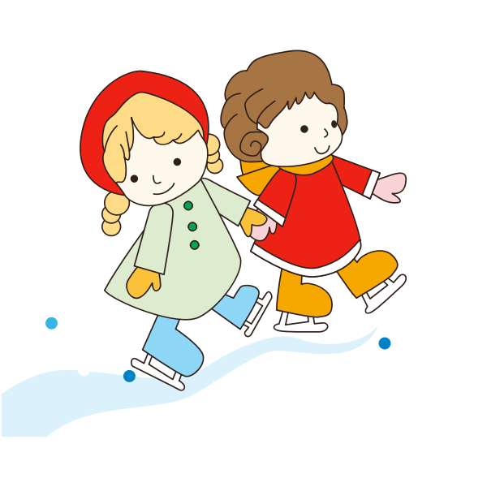

info@calalta.net 403-245-2425
www.calalta.net

Welcome to Calalta Figure Skating Club
Calalta is a non-profit, community-based skating club that operates out of Jimmie Condon. We strive to teach the magic of skating with quality, creativity and a strong technical standard. We thank you for choosing Calalta Figure Skating Club and look forward to another exciting and productive skating season with both our returning and new members.

Mission Statement

Calalta provides an environment that encourages each skater to achieve their personal best

Parent and Tot and Pre-CanSkate Program (Ages 3-5)
This program introduces children to basic skating movements on ice. They will learn skating skills such as: balance, standing and forward march. Parent must have skating experience to help their skater as needed. Helmets and mittens/gloves are mandatory.

CanSkate Program (Ages 4 & Up)
The objective of the Calalta CanSkate program is to teach children aged 4 and up the skills of ice skating that will be the foundation for pursuing all ice sports such as figure skating, hockey, ringette or speed skating. The children are immersed in a positive and fun, environment where they constantly receive encouraging feedback from our qualified teaching team.
The program will help skaters’ progress towards Calalta's Skate Canada Test and Competitive Programs. Achievement ribbons are given throughout the entire program.
During the year, coaches will use their discretion to progress skaters through appropriate group levels according to their skating ability.

What comes after CanSkate?

Pre-STAR Performance (Introduction to Figure Skating) CanSkate Stage 4 or higher
- The Pre-STAR Performance program is suited for skaters who are in Stage 4 or higher in CanSkate and who wish to continue in group lessons.
- This program will offer the skater the opportunity to begin their tests in skills and dance if they book a free skate session.
- Hiring a coach is required at this level if you book a free skate session

GroupStar (passed CanSkate Stage 4 or higher)
- A 60-minute-long group session that has a stroking component and a 30 minute off ice jump class.
- This program requires you to book a minimum of one junior free skate session of your choice for self-practice and private coaching with a Skate Canada professional coach.
Prestige Performance Group (passed CanSkate Stage 4 or higher)
- This program comprises of two weekly group lessons followed by a 30 minutes off ice jump class.
- This program requires you to book a minimum of one junior free skate session of your choice for self-practice and private coaching with a Skate Canada professional coach.

Skates and Gear
Skaters in the Pre-CanSkate to CanSkate Level 4 are allowed to use hockey or figure skates.
Figure skates are recommended for CanSkate level 4 and up.
To protect the skate blades, skate guards should be worn when in any area that is not protected by rubber mats. At the end of every session, the blades should be wiped with a dry cloth to prevent rusting.

Please ensure that all skates are sharpened regularly at least once a month. Hockey skates may be sharpened at any hockey skate specific store. Figure skates should be sharpened at Professional Skate Service.

Professional Skate Service (Marda Loop)
3515 18 Street SW Calgary à 403-243-3663

Skaters will progress faster if they are properly and safely equipped.
Help your skaters to ensure that:
• Skates fit comfortably
• There is room for toes to wiggle slightly
• Heels do not lift inside the skate more than ¼ inch
• An adult finger can fit in the top of the boot when done up.
• Excess laces are tucked or tied up so that they do not hang loose or drag on the ice

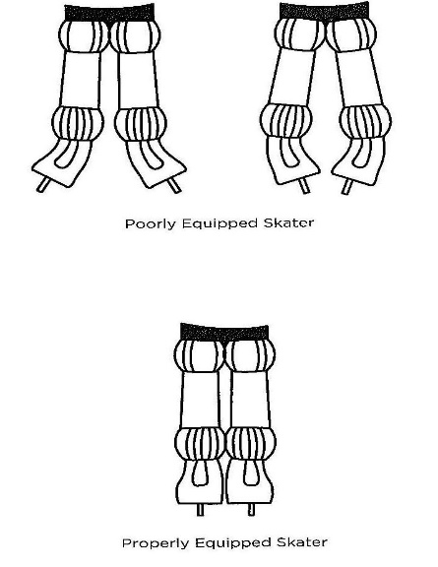

HELMETS
All skaters must wear a CSA approved helmet until they have passes their Stage 5 CanSkate badge. More information about helmets can be found in the Skate Canada Helmet Use Policy https://info.skatecanada.ca/hc/en-ca/articles/201219410-Helmet-Use-Policy

Attire
Please dress skaters appropriately. Sweats, track pants, snow pants and yoga pants are all good bottoms. Layers of long sleeve shirts, hoodies and vests allow for easy movement and warmth. Be sure to have a few pairs of mittens and gloves on hand. Items such as long drawstrings, scarves, dangling coat belts etc. can be a hazard on the ice and should be avoided.

Meet our CanSkate Coaching Team
JAIME-LYN JACKSON/Director of Group Programs
(403) 690-9598
Calaltagroupprogramsdirector@gmail.com

Skating Accomplishments: Former “Disney on Ice “Professional Skater; Former National Competitive Senior Synchro Skater; Gold Dance, Gold Skills, Sr. Silver Free Skate elements
Coaching Accreditation/Education: Certified Provincial Coach and can power certified. 16 years coaching experience. Analyze Technical & Tactile Performance Course, CanSkate University recipient. Developer and coach of Sectional, StarSkate champions and Alberta winter games medalist. Coach in both Competitive and StarSkate streams. Specialize in early development.

Certified CanSkate Coaches
Erin Harde
Cathy Sahaluk
Brad Hazelton
Nicole Grenon
Erin Matheson
Mercedes Shields
Ashley Czpionka

Program Dates 2022- 2023
Fall 2022 | Monday | Wednesday | Friday | Saturday
Canskate / Pre-Canskate | 4:45-5:30pm | 4:45-5:30pm | 6:15-7:00pm | 9:45-10:30am
September | 12, 19, 26 | 14, 21, 28 | 16, 23 | 17, 24
October | 3, 17, 24 | 12, 19, 26 | 14, 21, 28 | 1, 15, 22, 29
November | 7, 14, 2, 28 | 2, 16, 23, 30 | 4, 18, 25 | 5, 19, 26
December | 5, 12 | 7, 14 | 2, 9, 16 | 3, 10, 17

 | Monday | Wednesday | Friday | Saturday
POWER Skating |  |  |  | 5:15-6:15pm
September |  |  |  | 17, 24
October |  |  |  | 1, 15, 22, 29
November |  |  |  | 5, 19, 26
December |  |  |  | 3

 | Monday | Wednesday | Friday | Saturday
Adult/Teen Learn to Skate |  |  |  | 10:45-11:30am
September |  |  |  | 17, 24
October |  |  |  | 1, 15, 22, 29
November |  |  |  | 5, 19, 26
December |  |  |  | 3, 10, 17

 | Monday | Wednesday | Friday | Saturday
PreSTAR Performance | 5:30-6:15pm | 5:30-6:15pm
September | 12, 19, 26 | 7, 14, 21, 28
October | 3, 17, 24 | 5, 12, 19, 26
November | 7, 14, 21, 28 | 2, 9, 16, 23, 30
December | 7, 14, 21 | 7, 14, 21

Liability Disclaimer
Calalta Figure Skating Club is not liable for personal injuries or loss of or damage to personal property. Each skater may decline to participate in any activity. Please inform your coach of any personal limitations you may have. If you have any doubt about your personal physical abilities, please consult your physician before participating.
Got a registration question? Email or call Natalie/Dianne at the Calalta office at info@calalta.net or call 403-245-2425
On ice program questions can be directed to Jaime Lyn at Calaltagroupprogramsdirector@gmail.com

Track your skater’s progress through your registration account:
http://calalta.uplifterinc.com/
Log in with your email username and password
Select My Account from the top menu
Select skaters from the left side menu
Click on your skater
Select evaluations to view overall progress
Let us know if you have any questions

info@calalta.net

Emergency Plan of Action
In case of a fire alarm, skaters will exit through the South East doors of the arena and into the parking lot. There is no time for guards etc., so they will unfortunately be concrete. Secondary exit if needed through the North doors at the back of the arena beside the Zamboni area. Parents are asked to proceed through the main south facing front doors to the exit, and then meet their children in the parking lot.

HAPPY SKATING!

