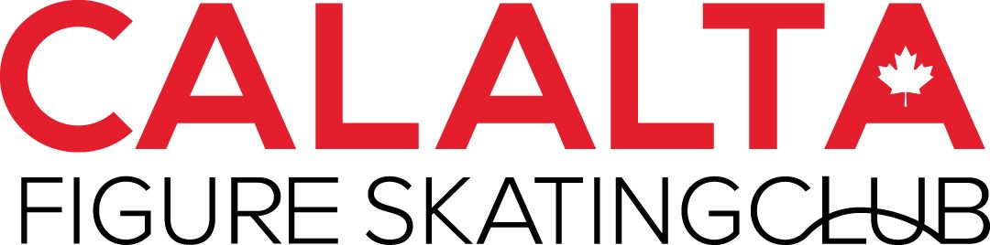

2025-2026 Handbook
for
Pre-CanSkate & CanSkate

Jimmie Condon Arena
502 Heritage Drive SW
Calgary, AB
T2V 2W2


info@calalta.net 403-245-2425
www.calalta.net

Welcome to Calalta Figure Skating Club
Calalta is a non-profit, community-based skating club that operates at Jimmie Condon. We strive to teach the magic of skating with quality, creativity and a strong technical standard. We thank you for choosing Calalta Figure Skating Club and look forward to another exciting and productive skating season with both our returning and new members.

Mission Statement

Calalta inspires excellence and the passion to skate.

CanSkate Program
Teaches children the skills of ice skating that will be the foundation for pursuing all ice sports such as figure skating, hockey, ringette or speed skating. The children are immersed in a positive and fun environment where they constantly receive encouraging feedback from our qualified teaching team. Achievement ribbons are given throughout the entire program.
Track your skater’s progress through your registration account:
http://calalta.uplifterinc.com/
Log in with your email username and password. Select My Account from the top menu. Select skaters from the left side menu. Click on your skater. Select evaluations to view overall progress

What comes after CanSkate?

PowerSkate
Suited for skaters who have achieved Stage 4 or higher in CanSkate and who wish to continue in sport specific training related to Hockey or Ringette. Full hockey gear including sticks are required for this program.

Pre-Star Performance (Introduction to Figure Skating)
Suited for skaters in Stage 4 or higher in CanSkate and who wish to continue in figure skating-specific group lessons. Group lessons are coach-led for the entire session and the program runs from September to June.
- Age range: 5-9 years of age (registrants are required to be aged 8 or under by July 1, 2025)
- Jimmie Condon Arena:
  - Mon OR Wed 5:15 pm - 6:00 pm
  - Off-Ice 6:10 -6:30 pm
- COP WinSport Arena:
  - Thursday 6:15-7:00 pm (includes 15 minutes of self-practice)
  - Off-ice 5:45-5:05 pm

GroupStar (passed CanSkate Stage 4 or higher)
- The GroupStar Skate program is best suited for skaters who have completed PSP, CanSkate 5 or higher, and is a more recreational program with less time commitment.

Teen StarSkate
- This program is best suited for Pre-Teens and Teens who have completed CanSkate or with previous experience in Prestige Performance.

Prestige Performance Group
- The Prestige Performance program is best suited for skaters who have completed the Pre-Star Performance or STAR 2-4 between ages of 5-9. Invitation program
For more information regarding group programming, please visit www.calalta.net for the Groups at a Glance information sheet or contact the office at info@calalta.net.
Skates and Gear
Skaters in CanSkate from PreCanskate through stage 4 are allowed to use hockey or figure skates.
Figure skates are required for PreStar Performance. Hockey skates are required for PowerSkate.
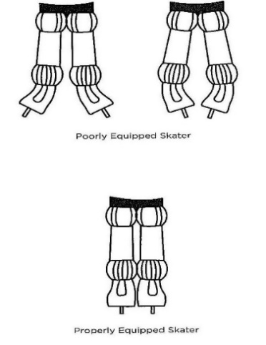
To protect all types of skate blades, hard skate guards should be worn when in any area that is not protected by rubber mats. At the end of every session, the blades should be wiped with a dry cloth too and stored in a soft guard cover to prevent rusting.
Please ensure that all skates are sharpened regularly at least once a month. Hockey skates may be sharpened at any hockey skate specific store. Figure skates should be sharpened at either Professional Skate Service or The Skate Lab.

Professional Skate Service (Marda Loop)
1070 42 Ave SE Calgary 403-243-3663
The Skate Lab
7777 Macleod Trail SW Calgary 825-413-5786

Skaters will progress faster if they are properly and safely equipped.
• Skates should fit comfortably
• There is enough room for toes to wiggle slightly (no bigger)
• Heels do not lift inside the skate more than ¼ inch
• An adult finger can fit in the top of the boot when done up.
• Excess laces are tucked or tied up so that they do not hang loose or drag on the ice

Helmets
All skaters in CanSkate (Parent and Tot, PreCanSkate, CanSkate, Adult and Teen learn to skate up to Stage 5) and PowerSkate must wear a CSA approved helmet. More information about helmets can be found in the Skate Canada Helmet Use Policy https://info.skatecanada.ca/hc/en-ca/articles/201219410-Helmet-Use-Policy

Attire
Please dress skaters appropriately- Sweatpants, track pants and yoga pants paired with long sleeve shirts, hoodies and vests over a base layer allow for easy movement and warmth. Be sure to have a few pairs of mittens and gloves on hand. Items such as long drawstrings, wide or long pant legs, scarves, dangling coat belts etc. can be a hazard on the ice and should be avoided. Jeans/Denim are not a good conductor of heat and are not acceptable attire.

Emergency Plan of Action
In case of a fire alarm, skaters will exit through the South Lobby doors of the arena and into the parking lot. There is no time for guards etc., so they will unfortunately be on concrete. A secondary exit if needed through the southeast door at the side of the arena beside the windows. Parents are asked to allow skaters to exit, and then meet their children in the parking lot.

Liability Disclaimer
Calalta Figure Skating Club is not liable for personal injuries or loss of or damage to personal property. Each skater may decline to participate in any activity. Please inform your coach of any personal limitations you may have. If you have any doubt about your personal physical abilities, please consult your physician before participating.

Meet our CanSkate Coaching Team
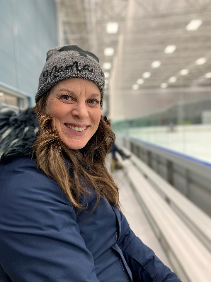 | LISA BRIGGS  CanSkate Coordinator  Skating Accomplishments: Former National Competitive Senior Synchro Skater; Regional and Sectional Gold Medalist;  former Junior synchro Regional and Sectional Gold Medalist and National Competitor. Former Adult Synchro National Competitive Synchro Skater; Regional and Sectional Gold Medalist. Former BC Winter Games Singles Competitor  Coaching Accreditation/Education: NCCP Certified Regional Coach;  NCCP Certified Provincal Coach;  20 years coaching experience;  Level 2 Certified Synchronized Skating Coach. Developer and coach of Sectional synchro team champions and Regional medalists; Teaches freeskate, dance, and skills in StarSkate streams.
CanSkate Coaches  Lisa Briggs  Andrea St. Cyr  Olivia Compton  Mercedes Shields  Natasha Purich  Jessica Behiel |  | Liel Oren  Julia Figura  Brooklyn Kidd  Kainos Yau  Erin Harde  Carlotta Edwards

Program Dates Winter 2026
 | Monday | Wednesday |  |  | Friday |  | Saturday
CanSkate & PreCanSkate | 4:35-5:15PM | 4:35-5:15pm |  |  | 6:20-7:00pm |  | 9:35-10:05am  or  10:05-10:45am
Jan | 5, 12, 19, 26 | 7. 14. 21.28 |  |  | 9, 16, 23, 30 |  | 10, 17, 24, 31
Feb | 2, 9, 23 | 4, 11, 18, 25 |  |  | 6, 13, 20, 27 |  | 7, 14, 21, 28
Mar | 2, 9, 16, 23, 30 | 4, 11, 18, 25 |  |  | 6, 13, 20, 27 |  | 7, 14, 21, 28
Apr Ice show (TBD) | 4 | 4 |  |  | 4 |  | 4
POWER Skating  Power 1 4:45-5:30  Power 2 5:30-6:15 pm |  |  |  |  |  | Saturday
Jan |  |  |  |  |  | 10, 17, 24, 31
Feb |  |  |  |  |  | 7, 14, 21, 28
Mar |  |  |  |  |  | 7, 14, 21, 28

Adult-9:35 – 10:05 am Teen 10:05-10:45 am  Learn to Skate |  |  |  | Saturday
Jan |  |  |  | 10, 17, 24, 31
Feb |  |  |  | 7, 14, 21, 28
Mar |  |  |  | 7, 14, 21, 28
Apr Ice show (TBD) |  |  |  | 4

Have a registration question? Email or call Natalie at the Calalta office at info@calalta.net or call 403-245-2425
On ice program questions can be directed to Lisa Briggs at info@calata.net

HAPPY SKATING!

