Yuka Sato Skating Clinic Announcement and Information
Calalta is pleased to partner with Yuka Sato for our next skating clinic!

Yuka is a Japanese former competitive figure skater. She is the 1994 World champion, the 1990 World Junior champion and the 1993 & 1994 Japanese national champion. She placed 7th at the 1992 Winter Olympics and 5th at the 1994 Winter Olympics.

Read more about Yuka https://en.wikipedia.org/wiki/Yuka_Sato. She will spend two days with Calalta working with our skaters in helping them master their edges, spins and jumps.

Monday June 20, 2016  Spinning and Jumps  All Sessions below are with Yuka |  | Tuesday June 21, 2016  Edges, Stroking and Performance  All Sessions below are with Yuka
12:30 – 1:30 pm | Ice - Pre-Nov to Senior | 12:30 – 1:30 pm | Ice - Pre-Nov to Senior
1:45 – 2:45 pm | Off Ice – Pre Novice to Sr | 1:45 – 2:45 pm | Off Ice – Pre Novice to Sr
3:00 - 4:00 pm | Ice – Pre Novice to Senior | 3:00 - 4:00 pm | Ice – Pre Novice to Senior
4:15 – 5:15 pm | Ice – Pre Juv to Juv | 4:15 – 5:15 pm | Ice – Pre Juv to Juv
5:30 – 6:30 pm | Ice – HP & Jr Prep | 5:30 – 6:30 pm | Ice – HP & Jr Prep
6:45 – 7:45 pm | Ice – Pre Juv to Juv | 6:45 – 7:45 pm | Ice – Pre Juv to Juv
Off Ice Sessions with Spencer
5:30 – 6:15 pm | Off Ice – Pre Juv to Juv | 5:30 – 6:15 pm | Off Ice – Pre Juv to Juv
6:45 – 7:30 pm | Off Ice – HP & Jr Prep | 6:45 – 7:30 pm | Off Ice – HP & Jr Prep

Please note:
- Pre Novice to Senior also includes skaters in Sr Silver and up;
- Pre Juvenile to Juvenile also includes skaters in Sr Bronze and Jr Silver;
- HP and Jr Prep also includes skaters in Star 3 to Star 5

Date: Monday and Tuesday June 20 and 21, 2016

Location: Winsport Arena - Canada Olympic Park
88 Canada Olympic Road SW
Calgary, AB, T3B 5R5
Joan Snyder Arena

Please ensure you are at COP at least 15 minutes PRIOR to your child skating. This allows time for a quick warm up and to get your skates on. Please ensure your skater has the proper gear for the sessions – runners, skipping ropes and water for the off ice session. Parents are more than welcome to watch from the bleachers located on the Main floor of COP, next to the Garden Café. All off ice sessions are held next to Joan Snyder rink. Please note there are two change rooms – one for males and one for females both of which will be labeled. Please ensure you are using the proper one!

Check In will be on the Event level (ice level) outside Joan Snyder rink.

Costs | Monday June 20 ONLY | Tuesday June 21 ONLY | BOTH  Monday and Tuesday
Pre-Novice to Senior and Jr Silver and Higher | $75 | $75 | $130 | 2 hrs on ice and 1 hr off ice with Yuka
Pre-Juvenile to Juvenile and Sr Bronze | $60 | $60 | $110 | 2 hours on ice with Yuka and 1 hr off ice with Spencer
HP and Jr Prep and Star 3 – Star 5 | $40 | $40 | $70 | 1 hr on ice with Yuka and 45 min off ice with Spencer
To register, have your credit card ready and please click here: https://calalta.wufoo.com/forms/zk4bue61d62jmh/ |  |  |  | Sorry no registering for individual sessions!

Registration opens to Calalta members on May 18 so register early!! If there are spots available, registration opens to the public on May 31. Once registered, there are no refunds.

Attention COP Skaters:
- There is no NPC ice the week of June 20-24;
- If you are a Calalta skater and you normally skate Monday June 19 from 4 pm to 6:45 pm at COP, your session will move to Wednesday June 21 at the same time;
- If you are a Calalta skater and you normally skate Tuesday June 20 at COP from 4 pm to 6:45 pm, your session will move to Thursday June 22 at the same time;

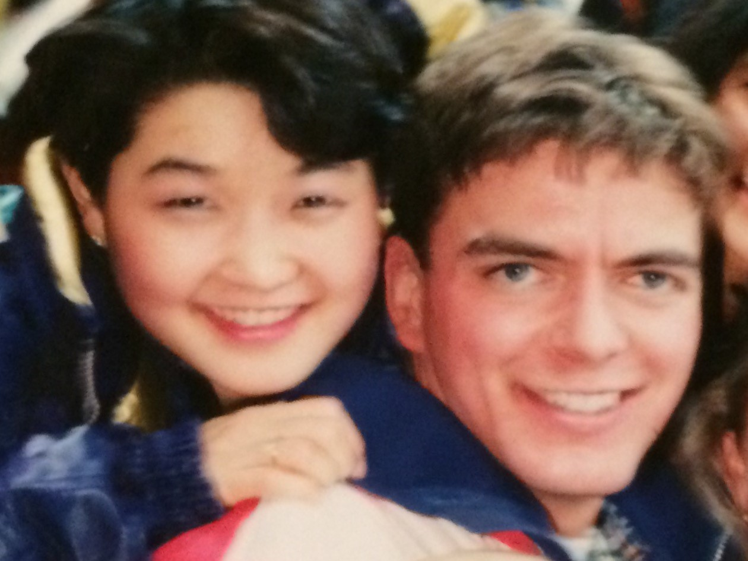

Scott and Yuka in their glory days at the 1994 Olympics

