Calalta’s Code of Conduct

This code of conduct applies to all skaters and Calalta members:

- Represent Calalta Figure Skating Club in a respectful and professional manner;

- Strive to create and maintain cooperative relationships between skaters, parents and coaches for the purpose of ensuring a positive skating environment;

- Non-payment of club fees will result in withdrawal of skating privileges. Volunteer deposit must accompany registration – no volunteer deposit? Your registration will be cancelled;

- Parents are responsible for the behavior of their children;

- Inappropriate and disrespectful behavior by skaters and/or parents can result in temporary or permanent suspension from Calalta FSC – see the Skating Etiquette poster for more details;

- There will be no bullying, victimizing, harassing (sexual or otherwise), impersonating, vandalizing or stealing from another skater. Disciplinary actions may include suspension or expulsion from the club;

- All skaters are to display good sportsmanship and encourage all skaters' enjoyment of skating;
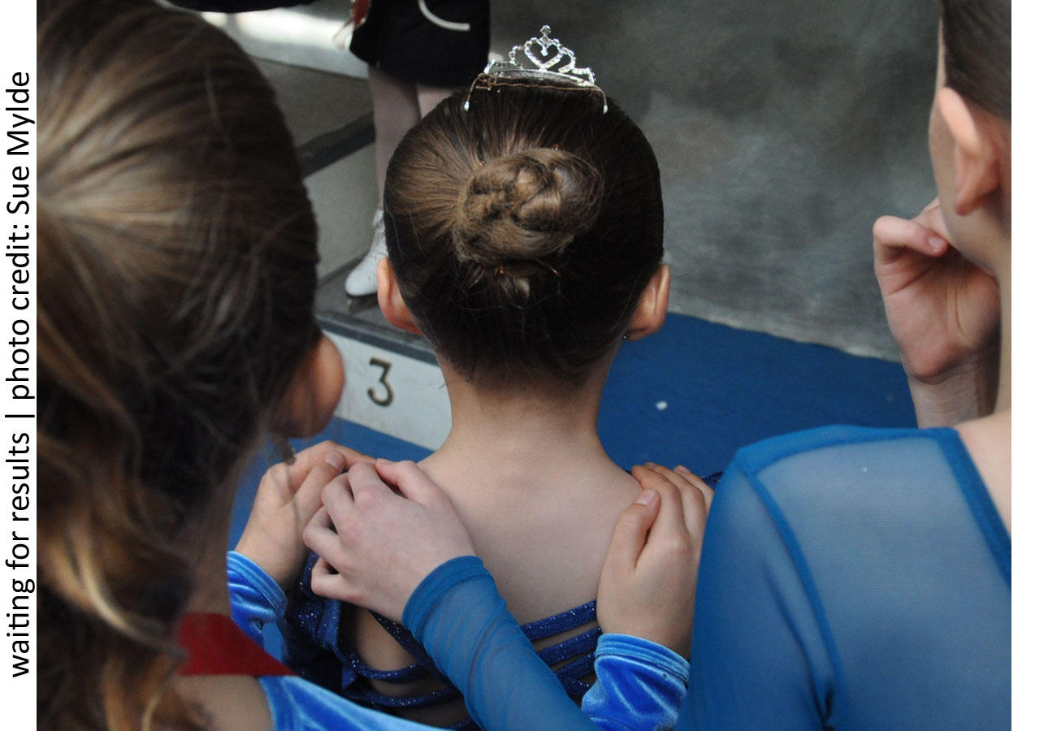
- All skaters are responsible for keeping the dressing rooms clean and tidy. The skaters are responsible for putting away their own personal items and throwing away any garbage. Skaters are also expected to use his/her respective dressing rooms;

Any and all concerns with the Code of Conduct can be directed to the office in writing.

