HOW TO ACCESS YOUR SKATER’S SKATE CANADA RECORDS – FIRST TIME USER
- Go to the Skate Canada Website https://skatecanada.ca/

- On the top right corner you will see


Click on the “Members” link (Circled in red above). You will be taken to a new screen for “members only” that houses various information from Skate Canada

- On the top right corner of this second screen, you will see

Click on the “Sign in” (Circled in red above). You will be taken to a new screen requesting your user name.

- You should see the screen below. As a first time user, you will need to request an invitation code from Skate Canada (this is their security measure to ensure only registered skaters have access to their skate Canada records). Click on the “Request Invitation Code”(circled in red below). Be sure to have your skater’s registration details ready. They will ask you for your email address and your birthday – it must match the information found in your skater’s registration profile. This should be the information that you provided to Calalta through your uplifter account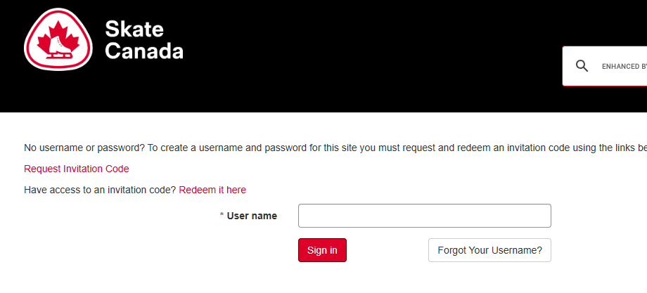
- After you get an email from Skate Canada with your “invitation code”, click on the “Redeem it here” (circled in red below)

- From here it takes you to another screen where you will enter your invitation code and set up your on line log in details as a member to Skate Canada.

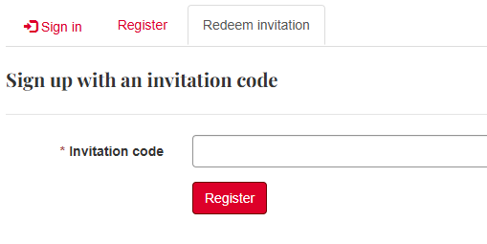
CALATLA WILL NOT HAVE ACCESS TO YOUR SKATE CANADA LOG IN DETAILS. IF YOU HAVE ANY PROBLEMS OR QUESTIONS PLEASE CONTACT SKATE CANADA DIRECTLY AT:
Phone: 613-747-1007
Toll Free: 1-888-747-2372 or 1-877-211-2372
E-mail: info@skatecanada.ca

